# Fun Card

Create a Web page (HTML5 + CSS3) that looks and behaves like the screenshot below:

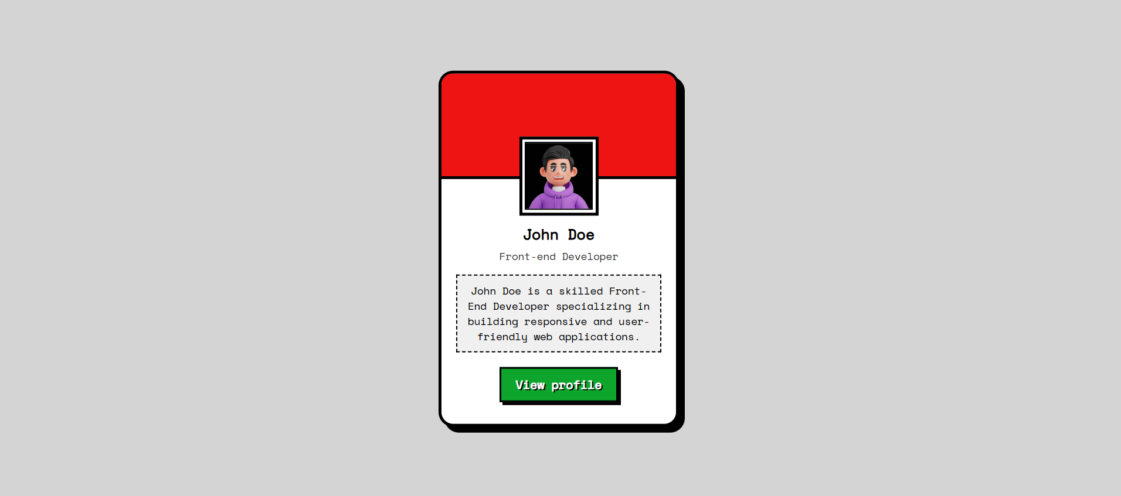

### Output

The output should be valid **HTML5** + **CSS3** + **images** that implement the above web page.

* Use the Google fonts **Space Mono** - (<https://fonts.googleapis.com/css2?family=Space+Mono&display=swap>)
* The site should open correctly in the **latest** version of **Chrome**